LAB 2
PROGRAM 2
Gene expression algorithm – Financial modelling and forecasting
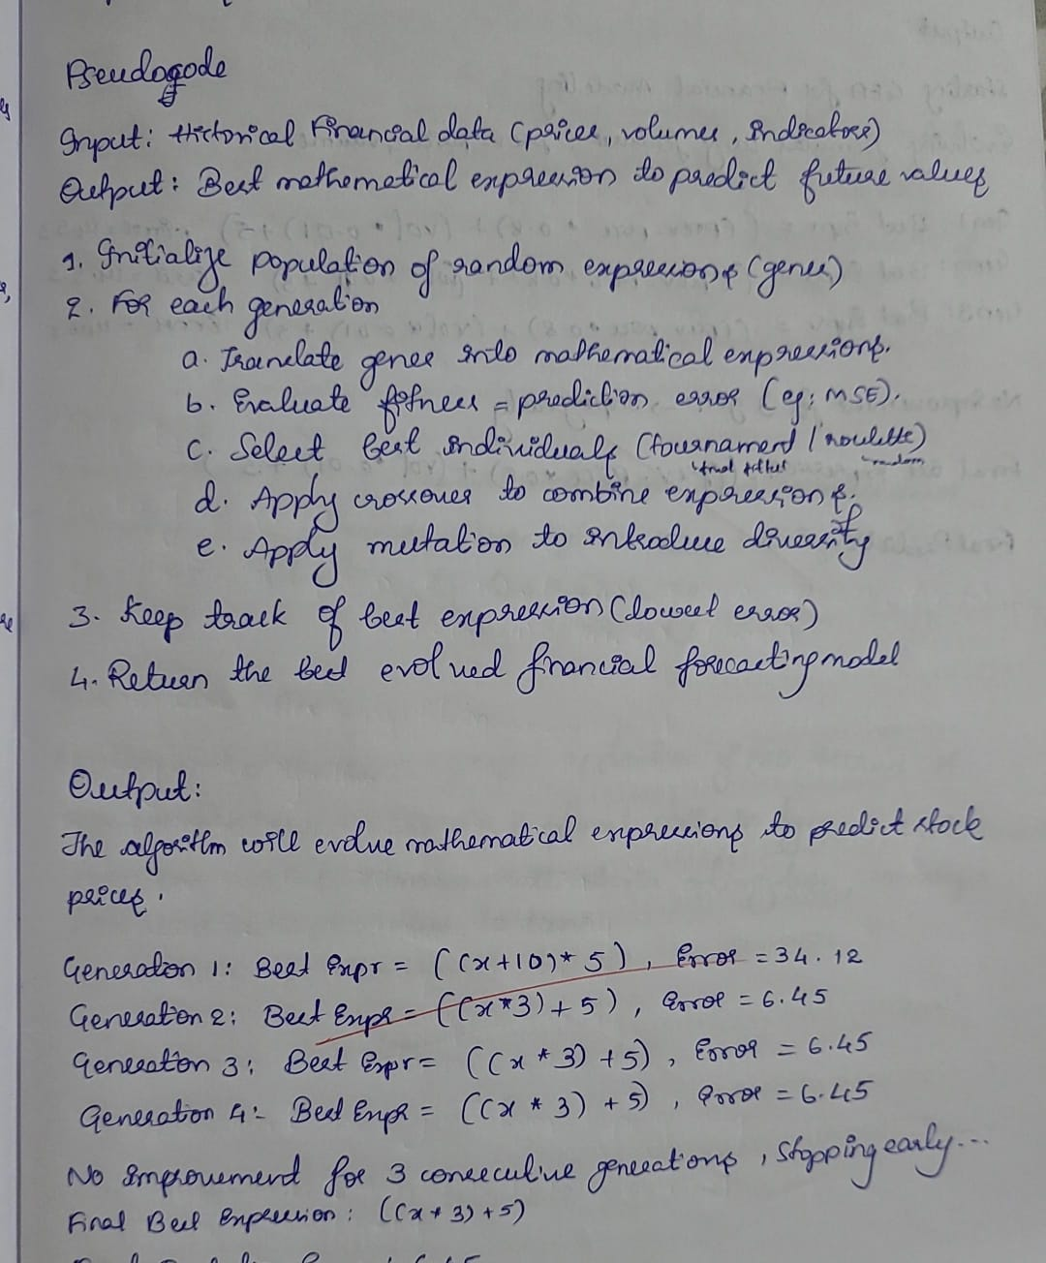

Code:
import random
import numpy as np

# ------------------------------
# 1. Create synthetic financial dataset
# ------------------------------
np.random.seed(42)
days = 40
prev_price = np.linspace(100, 140, days) # yesterday's stock price
volume = np.random.randint(1000, 5000, days) # trading volume
# True formula: price ≈ 0.8*prev_price + 0.01*volume + 5 + noise
y_data = 0.8 * prev_price + 0.01 * volume + 5 + np.random.normal(0, 2, days)

# ------------------------------
# 2. Define operators & terminals
# ------------------------------
OPERATORS = ['+', '-', '*']
TERMINALS = ['prev_price', 'volume', '5', '10']

def random_expr(depth=2):
"""Generate random expression tree as a string."""
if depth == 0:
return random.choice(TERMINALS)
op = random.choice(OPERATORS)
return f"({random_expr(depth-1)} {op} {random_expr(depth-1)})"

def eval_expr(expr, i):
"""Evaluate expression for a given day i."""
try:
return eval(expr, {"prev_price": prev_price[i], "volume": volume[i]})
except:
return float('inf')

def fitness(expr):
"""Mean Squared Error between predicted and actual values."""
preds = [eval_expr(expr, i) for i in range(len(y_data))]
if float('inf') in preds:
return float('inf')
return np.mean((np.array(preds) - y_data) ** 2)

def mutate(expr):
"""Mutation: randomly replace with new random expression."""
return random_expr(depth=2) if random.random() < 0.3 else expr

def crossover(expr1, expr2):
"""Crossover: randomly choose one parent's expression."""
return expr1 if random.random() < 0.5 else expr2

# ------------------------------
# 3. Gene Expression Algorithm (GEA)
# ------------------------------
def GEA(pop_size=20, generations=50, patience=3):
print("Starting GEA for Financial Modeling...")
print("Evolving formulas using features: prev_price and volume\n")

# Initialize random population
population = [random_expr(depth=3) for _ in range(pop_size)]
best_expr, best_fit = None, float('inf')
same_count = 0

for gen in range(generations):
# Compute fitness
fitness_values = [fitness(expr) for expr in population]
gen_best_idx = np.argmin(fitness_values)

# Update best
if fitness_values[gen_best_idx] < best_fit:
best_fit = fitness_values[gen_best_idx]
best_expr = population[gen_best_idx]
same_count = 0
else:
same_count += 1

print(f"Gen {gen+1}: Best Expr = {best_expr}, Error = {best_fit:.2f}")

# Early stopping if no improvement
if same_count >= patience:
print("\nNo improvement for 3 gens → stopping early.\n")
break

# Tournament selection
selected = []
for _ in range(pop_size):
a, b = random.sample(range(pop_size), 2)
winner = population[a] if fitness_values[a] < fitness_values[b] else population[b]
selected.append(winner)

# Generate offspring
offspring = []
for i in range(0, pop_size, 2):
child1 = mutate(crossover(selected[i], selected[i+1]))
child2 = mutate(crossover(selected[i+1], selected[i]))
offspring.extend([child1, child2])

population = offspring

return best_expr, best_fit

# ------------------------------
# 4. Run GEA
# ------------------------------
best_expression, error = GEA()
print("Final Best Expression:", best_expression)
print("Final Prediction Error (MSE):", error)

OUTPUT:
